**Increment /Decrement operator & While Loop**

|  |
| --- |
| #include <iostream>  using namespace std;  int main()  {  int x=77,a;  a=--x;  cout<<"pre Decrement Operator";  cout<<"\na = "<<a;  cout<<"\nx ="<<x;  int y=45,n;  n=y--;  cout<<"\nPost decrement operator";  cout<<"\na = "<<y;  cout<<"\nx ="<<n;  return 0;  } |

Output

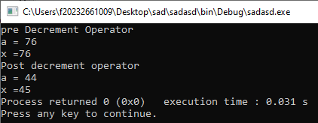

**While Loop:**

**Example 1: Write a program using while loop that show the sum of first five numbers.**

|  |
| --- |
| #include<iostream>  using namespace std;  int main()  {  int number=1,sum=0;  while(number<=20)  {  sum = sum + number;  number++;  }  cout<<"Sum is "<<sum;  return 0;  } |

Output

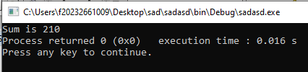

**Example 2: Write a program for take input the list of numbers and print their squares.**

|  |
| --- |
| #include <iostream>  using namespace std;  int main()  {  int minimum=1;  int maximum=5;  int num=minimum;  cout<<"Number number squared \n ";  while(num<=maximum)  {  cout << num <<"\t\t" << num * num << endl;  num++;  }  return 0;  } |

Output

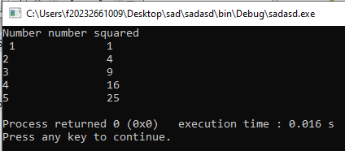

**Example 3: Write a program in C++ to find the factorial of a number.**

|  |
| --- |
| #include <iostream>  using namespace std;  int main()  {  int num;  cout<< "Input a number to find the factorial:";  cin>>num;  int factorial = 1;  int i = 1;  while (i <= num)  {  factorial = factorial*i;  i++;  }  cout << factorial;  return 0;  } |

Output

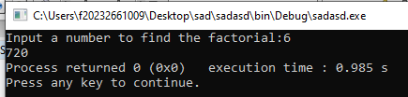

**Example 4: A class of ten students took a quiz. The grades (integers in the range 0 to 100) for this quiz are available to you. Calculate and display the total of all student grades and the class average on the quiz.**

|  |
| --- |
| #include <iostream>  using namespace std;  int main()  {  int total;  int gradeCounter;  int grade;  double average;  total = 0;  gradeCounter = 1;  while ( gradeCounter <= 10 )  {  cout << "Enter grade: ";  cin >> grade;  total = total + grade;  gradeCounter = gradeCounter + 1;  }  average = total / 10;  cout << "\nTotal of all 10 grades is " << total << endl;  cout << "Class average is " << average << endl;  return 0;  } |

Output

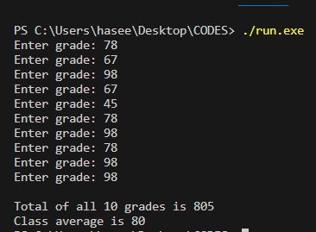

**Example 5: Develop a class averaging program that will process an arbitrary number of grades each time the program is run.**

|  |
| --- |
| # include <iostream>  # include <iomanip>  using namespace std;  int main()  {  int total=0;  float average;  int grade;  int gradecounter = 1;  while(grade != -1)  {  cout << "Enter the grades or close: ";  cin >> grade;  gradecounter = gradecounter + 1;  }  cout << setprecision(4);  if(gradecounter != 0)  {  average = static_cast<float>(total)/gradecounter;  cout << "class average is: " << average;  }  else{  cout << "no grades were entered"<< endl;  }  return 0;  } |

Output

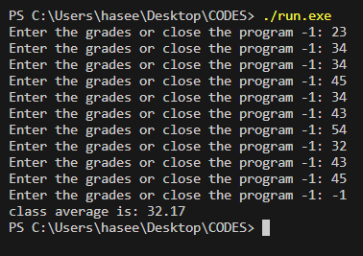

**Example 6: A college has a list of test results (1 = pass, 2 = fail) for 10 students. Write a program that analyzes the results. If more than 8 students pass, print "Raise Tuition".**

|  |
| --- |
| int main(){       int passes{0};     int failures{0};     int student_count{1};     int result{0};     while (student_count <= 10)     {      cout << "Enter 1 or pass and 2 for fail: ";      cin >> result;      if (result == 1)      {          passes = passes + 1;      }else if(result == 2)      {          failures++;      }       student_count = student_count + 1;     }      cout << "Total passes: " << passes<< endl;      cout << "Total fails: " << failures<< endl;     if (passes > 8)      {          cout << "Raise tuition";      }      return 0;  } |

Output

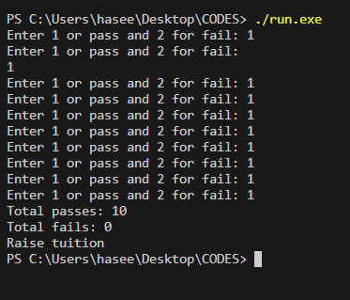

**Example 7: Write a program to Printing and count Even and Odd Numbers using While Loop in C++.**

|  |
| --- |
| #include<iostream>  using namespace std;  int main()  {      int i {1};      int num;      int odd {0};      int even {0};      cout<<"Enter the Ending value: ";      cin>>num;      while(i<=num)      {          if(i%2==0)          {              cout<<"Even numbers: ";              cout<< i << endl;              even++;          }          else          {              cout<<"Odd numbers: ";              cout<< i << endl;              odd++;           }          i++;      }      cout<<"\nTotal even numbers:"<<even;      cout<<"\nTotal odd numbers:"<<odd;      return 0;  } |

Output

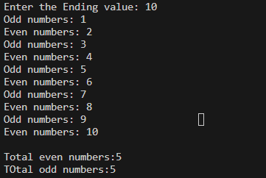

OR

|  |
| --- |
| #include<iostream>  using namespace std;  int main()  {      int i=1,n,even=0,odd=0;      cout<<"Enter the Ending value:";      cin>>n;      cout<<"Even numbers: ";      while(i<=n)      {          if(i%2==0)          {              cout<<"\n"<<i;              even++;          }          i++;      }      cout<<"\nOdd numbers:";      i=1;      while(i<=n)      {          if(i%2==1)          {              cout<<"\n"<<i;              odd++;          }          i++;      }      cout<<"Total even numbers: "<< even << endl;      cout<<"Total odd numbers: "<<odd << endl;      return 0;  } |

Output

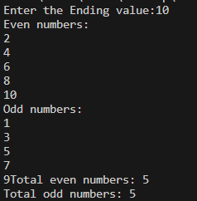

**Example 8: Write a program to check Even and Odd Numbers using While Loop on the basis of user choice in C++.**

|  |
| --- |
| #include <iostream>  using namespace std;  int main()  {      int choice = 1;      while( choice == 1 )  {          int a;          cout << "Enter a number to check even or odd: ";          cin >> a;          if( a%2 == 0 ){              cout << "Your number is even" << endl;          }          else{              cout << "Your number is odd" << endl;          }          cout << "Want to check more : 1 for yes and 0 for no" << endl;          cin >> choice;      }      cout << "I hope you checked all your numbers" << endl;      return 0;  } |

Output

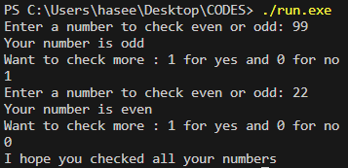

How work

Q: 1 2 3 6 18 13 21 34 55 89.

|  |
| --- |
| #include <iostream>  using namespace std;  int main()  {      int a {1};      int b {1};      int othervalue {};      while (othervalue <= 65)      {          a;          othervalue = a + b;          cout << othervalue << ",";          a = b;          b = othervalue;      }        cout << "good ho gaya a.";      return 0;  } |

Output

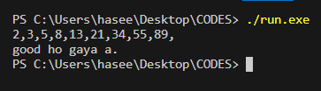

Q2 : 0 3 6 9 12 15 .. …

|  |
| --- |
| #include <iostream>  using namespace std;  int main()  {      int a {0};      int b {3};          while (a < 100)      {          cout <<"\n multiples of : " <<  a ;          a = a + b;      }      return 0;  } |

Output

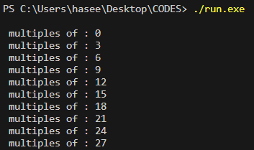

Q3: 1 2 3 6 18

|  |
| --- |
| #include <iostream>  using namespace std;  int main() {      int num = 1;      int i = 0;      while (i < 7) {          cout << num;          if (i < 6) {              cout << " ";              if (i % 2 == 0) {                  num *= 2;              } else {                  num *= 1.5;              }          }          ++i;      }      cout << endl;      return 0;  } |

Output

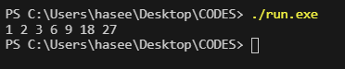

Q4: 4000 1000 250 125 62 31 15 7 3 1

|  |
| --- |
| #include <iostream>  using namespace std;  int main(){      int num {0};      int value {4000};      while (value > num)      {          cout << value << " ";          value = value / 2;      }        cout << "thanks";      return 0;  } |

Output

